22 Sep 2024
22 Sept Order of Service (for Service Sheets)
Welcome
Declaration - 1 Tim 6:15-16
Song 1 - Crown Him with Many Crowns
Song 2 - King of Kings, Majesty
Confession
Lord's Supper
Offering
Bible Reading - Mark 6:1-6; Mark 10:33-34
Prayer
Announcements
Kids' Song - W-I-S-D-O-M
Song 3 - Your Word
Bible Reading - Genesis 37:2-36
Closing Song - Come Behold the Wondrous Mystery

Crown Him with Many Crowns

C
[Verse 1]
C F
Crown Him with many crowns
C F G7
The Lamb upon His throne
C D G
Hark how the heavenly anthem drowns
G Dsus4 G
All music but its own
C F
Awake, my soul, and sing
D G
Of Him who died for thee
C F G7 C
And hail Him as thy matchless King
F G7 C
Through all e - ter – ni - ty

[Verse 2]
C F
Crown Him the Lord of life
C F G7
Who triumphed o’er the grave
C D G
And rose victorious in the strife
G Dsus4 G
For those He came to save
C F
His glories now we sing
D G
Who died and rose on high
C F G7 C
Who died eternal life to bring
F G7 C
And lives that death may die

[Verse 3]
C F
Crown him the Lord of love;
C F G7
behold his hands and side,
C D G
rich wounds, yet visible above,
G Dsus4 G
in beauty glorified;
C F
no angels in the sky
D G
can fully bear that sight,
C F G7 C
but downward bends their burning eye
F G7 C
at mysteries so bright.

[Verse 4]
C F
Crown him the Lord of years,
C F G7
the potentate of time,
C D G
creator of the rolling spheres,
G Dsus4 G
ineffably sublime.
C F
All hail Redeemer, hail
D G
For Thou hast died for me
C F G7 C
Thy praise and glory shall not fail
F G7 C
Through-out eter - nity

King of kings, Majesty

[Verse]
A E A
KING OF KINGS, MAJESTY
D E A
GOD OF HEAVEN, LIVING IN ME
E A
GENTLE SAVIOUR, CLOSEST FRIEND
D E F#m
STRONG DELIVERER, BEGINNING AND END
D C#m Dmaj7 E
ALL WITHIN ME FALLS AT YOUR THRONE

[Chorus]
A E F#m
YOUR MAJESTY I CAN BUT BOW
D A Bm E
I LAY MY ALL, BEFORE YOU NOW
A E F#m
IN ROYAL ROBES I DON’T DESERVE
E D E A
I LIVE TO SERVE YOUR MAJESTY

[Verse]
A E A
EARTH AND HEAVEN, WORSHIP YOU
D E A
LOVE ETERNAL, FAITHFUL, AND TRUE

WHO BOUGHT THE NATIONS,
E A
RANSOMED SOULS
D E
BROUGHT THIS SINNER NEAR TO YOUR
F#m
THRONE
D C#m Dmaj7 E
ALL WITHIN ME CRIES OUT IN PRAISE

CHORUS x2

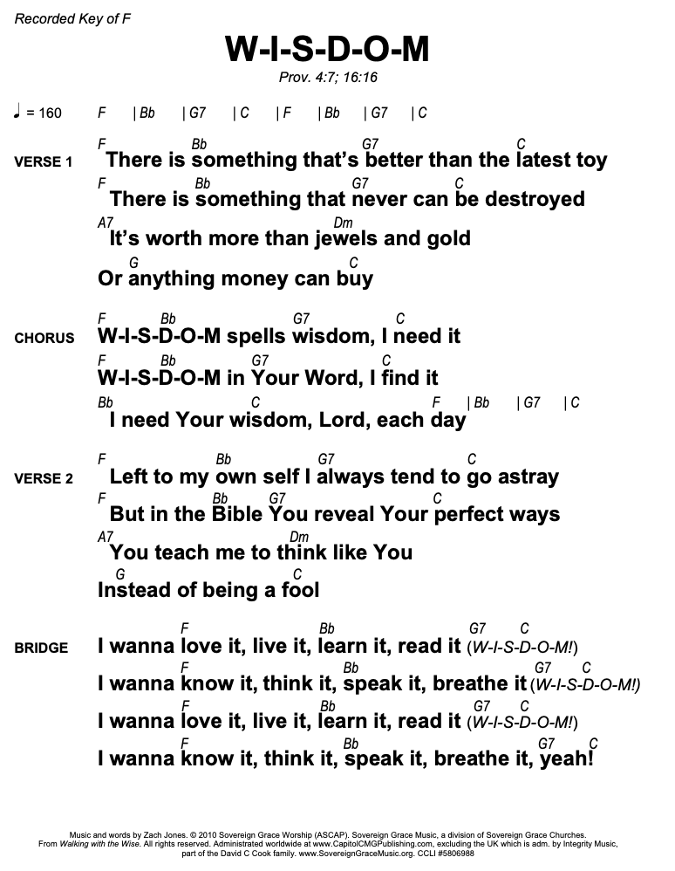

Your Word
[Intro]
Em C G x2

[Verse 1]
Em C G
Your word is good, it’s ever faithful
Em C G
Worth more than gold, the heart’s delight
Em C G
Your word gives life to all who hear and obey
Em C G D*
Your word endures forever

[Verse 2]
Em C G
Your word is true, it never changes
Em C G
It formed the earth; sustains it still
Em C G
Your word defends; providing refuge and strength
Em C G D
Your word endures forever

[Chorus]
Em C G D
Your word is a lamp unto my feet
Em C G D
Your word is a light unto my path
Em D G C
For your word is my hope, it’s my joy and my song
Em D C
Your word endures forever

[Verse 3]
Em C G
Your word transforms, it lifts the humble
Em C G
Rebukes the proud, protects the poor

Em C G
Your word discerns the mind and spirit of all
Em C G D
Your word endures forever
Em C G D
Your word endures forever

CHORUS

[Bridge]
C D
Your word is more than just letters on pages
Em D
It’s life and it's love and it's freedom for us
C D
Your word is more than just wisdom of ages
Em D
It's treasures are endless, it's always enough
C D
Your word is more than just stories of old
Em D
It's the truth and the way and the story of love
C D
Your word is more than just breath into dust
Em D
It’s your Son, as a man, come to dwell here with us

[Final Chorus]
Em* C* G* D*
Your word is a lamp unto my feet
Em* C* G* D*
Your word is a light unto my path
Em C G D
Your word is a lamp unto my feet
Em C G D
Your word is a light unto my path
Em D G C
For your word is my hope, it's my joy and my song
Em D C
Your word endures forever x3
Come behold the wondrous mystery
Intro: D G Bm A

[Verse 1]
D G
Come behold the wondrous mystery
D A
In the dawning of the King
Bm G
He the theme of heaven’s praises
A D
Robed in frail humanity
D/F# G D/F#
In our longing, in our darkness
D Bm A G
Now the light of life has come
D/A G
Look to Christ, who condescended
G A D
Took on flesh to ransom us

G Bm A

[Verse 2]
D G
Come behold the wondrous mystery
D A
He the perfect Son of Man
Bm G
In His living, in His suffering
G F#/D Em A D
Never trace nor stain of sin
D/F# G D/F#
See the true and better Adam
D Bm A G
Come to save the hell-bound man
D/A
Christ the great and sure
G
fulfillment
G A D
Of the law; in Him we stand
D G D A

[Verse 3]
Bm G
Come behold the wondrous mystery
Bm A/B
Christ the Lord upon the tree
Bm G
In the stead of ruined sinners
A D
Hangs the Lamb in victory
D/F# G D/F#
See the price of our redemption
D Bm A G
See the Father’s plan unfold
D/A G
Bringing many sons to glory
G A D
Grace unmeasured, love untold

[Verse 4]
D G
Come behold the wondrous mystery
D A
Slain by death the God of life
Bm G
But no grave could e’er restrain Him
A D
Praise the Lord; He is a-live!
D/F# G D/F#
What a foretaste of deliverance
D Bm A G (Diamond)
How unwavering our hope
D/A G
Christ in power resurrected
G A D
As we will be when he comes

Intro:
D C# B, A F#, A E x2

